Problem1: Landscape classification

Problem2: Cat vs Dog vs Wild classification

Contents

Problem 1 1

First model 3

Second model 4

Third model 5

Problem 2 7

Dataset statistics and data generation 7

Training and evaluation 11

# Problem 1

Dataset link: <https://www.kaggle.com/datasets/utkarshsaxenadn/landscape-recognition-image-dataset-12k-images?select=BiT-LR-91-83.h5>

This is a dataset that contains pictures of different landscapes:

* Coast
* Desert
* Forest
* Glacial
* Mountain

Each class has 2000 pictures associated

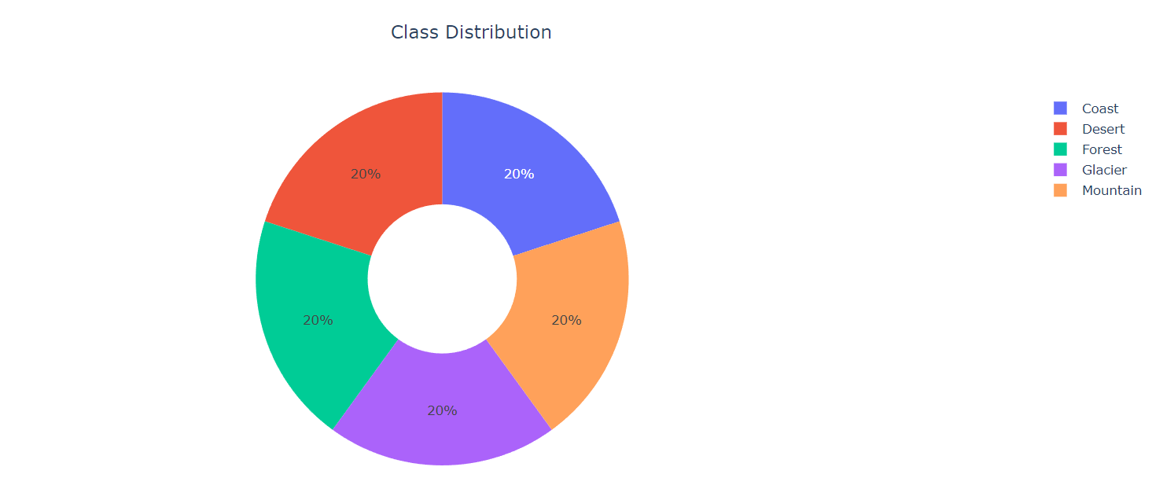

For the first three models, the dataset was splitted into train_ds and val_ds with validation_split = 0.2 and for the other two models the splitting coefficient was changed to 0.3.

For the last two models, data augmentation was used.

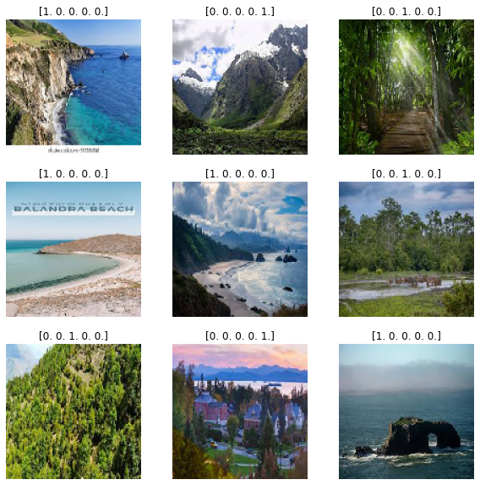

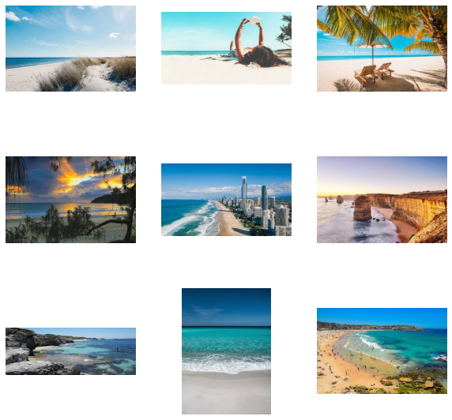Coast Desert

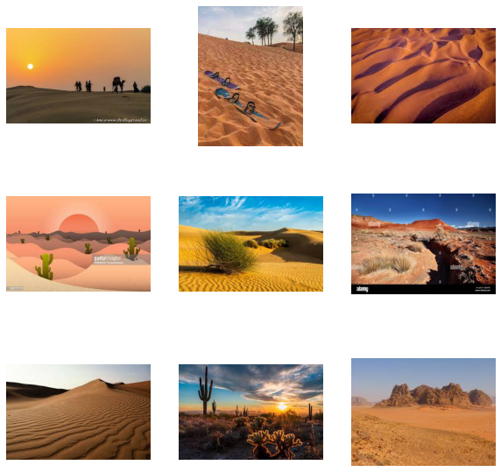

Forest Glacier

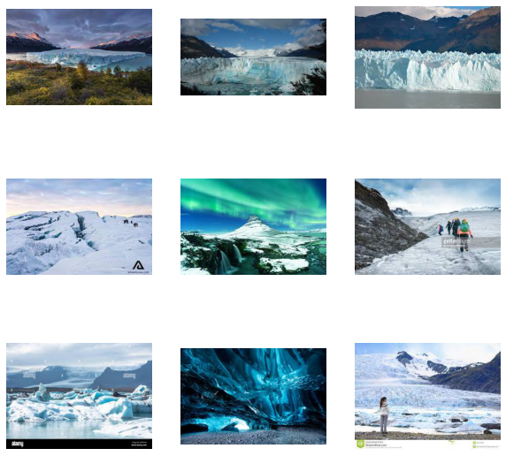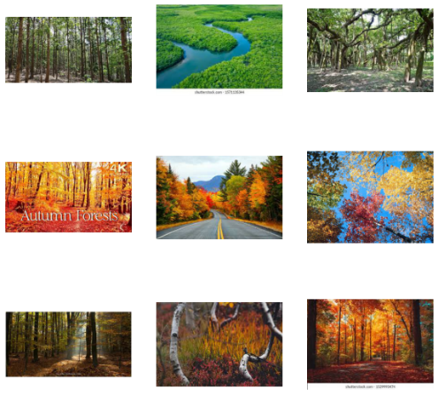

Mountain

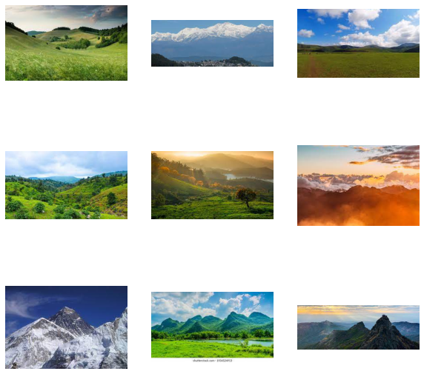

## First model

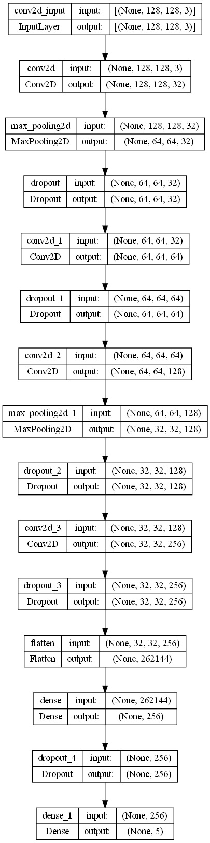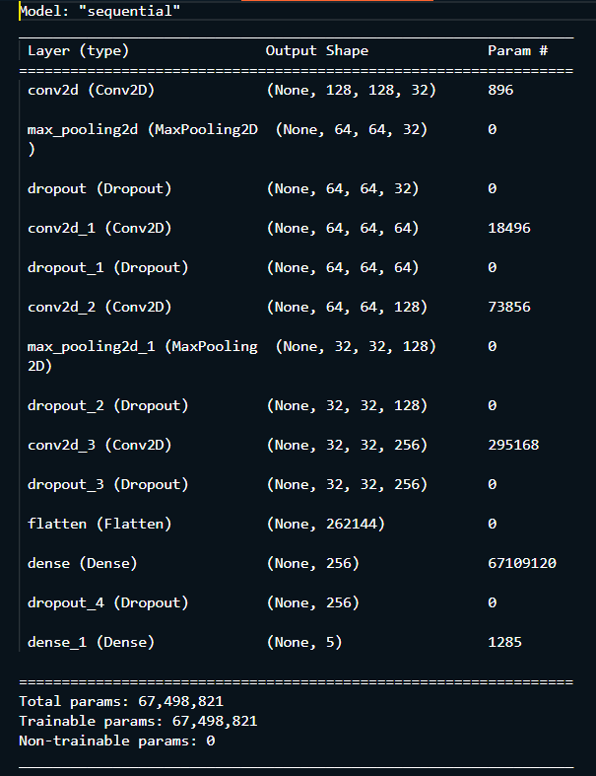

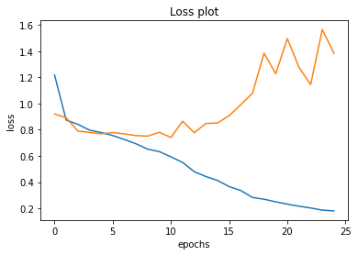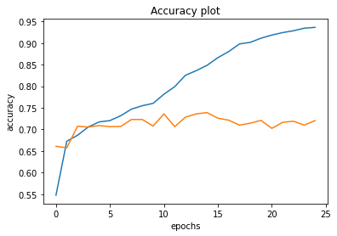

## Table Description automatically generatedSecond model

For this model, the validation split was 0.3 resulting in 7000 images in training dataset and 3000 in validation dataset.

The number of epochs used for fitting this model was 40

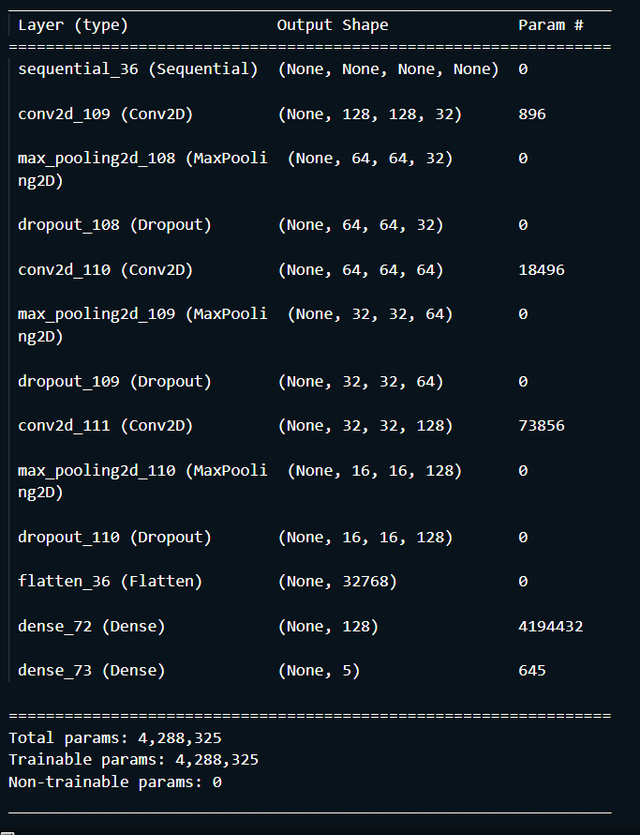

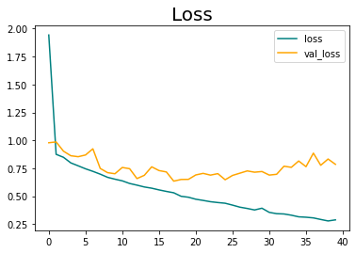

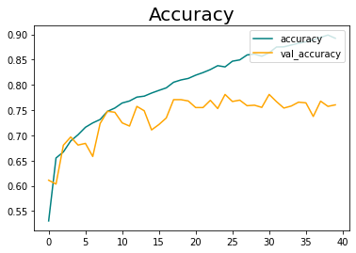

## Third model

For this model, for the first dense layer I used a kernel regularizer and the optimizer used was SGD instead of adam. After the first layer a dropout layer was added. The training was stopped at epoch 62/80 because in ten epochs val_loss was not getting a lower value.

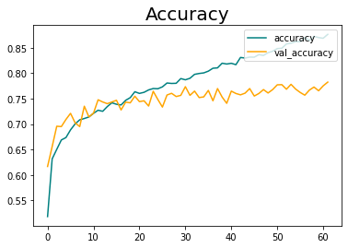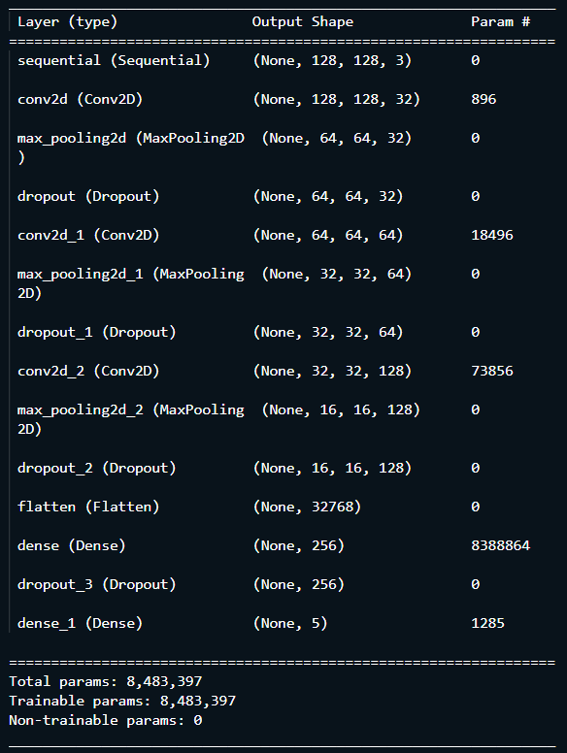

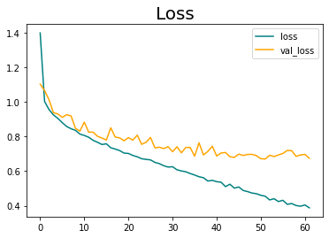

Results with images opened using cv2

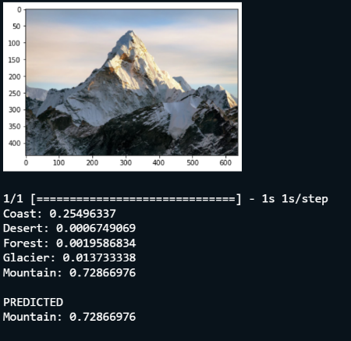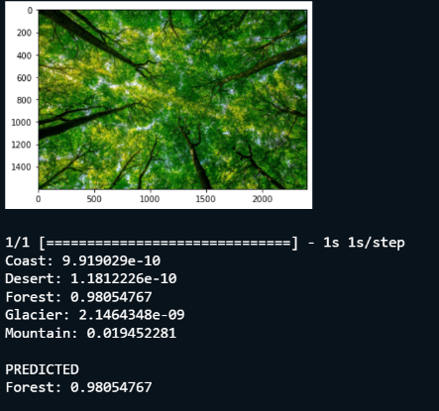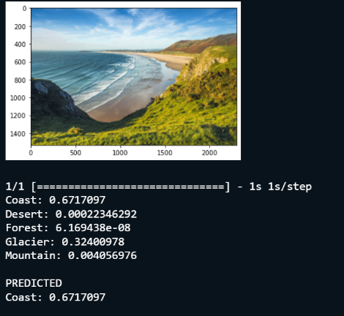

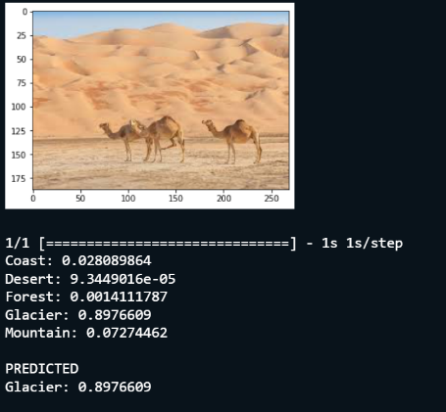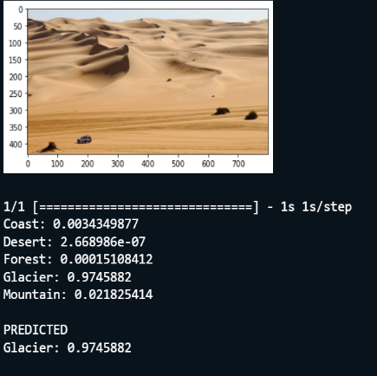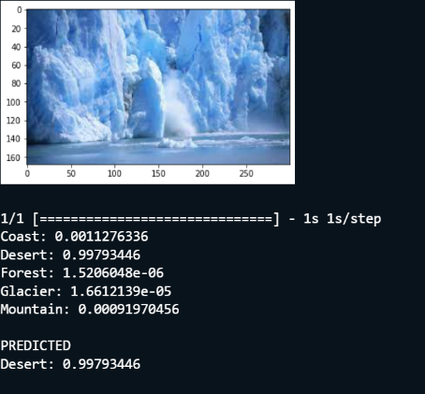

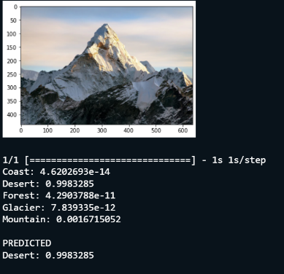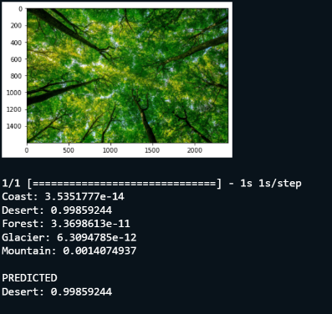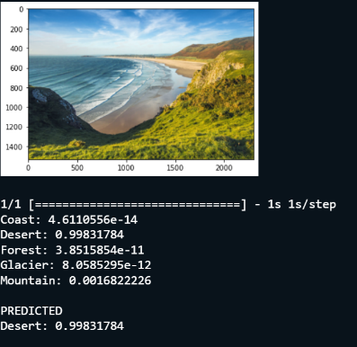Results with images opened using matplotlib.image

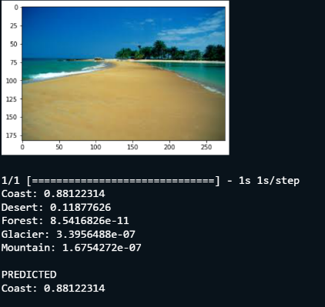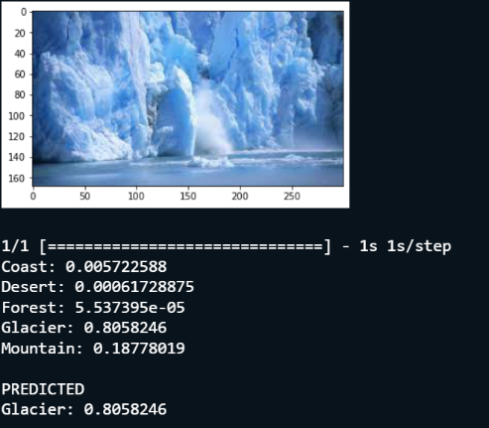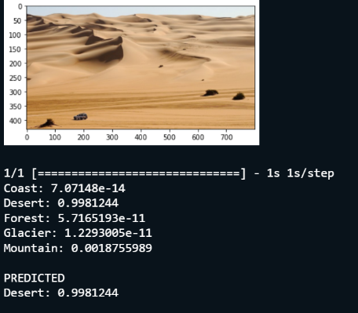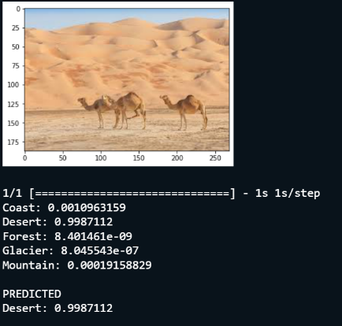

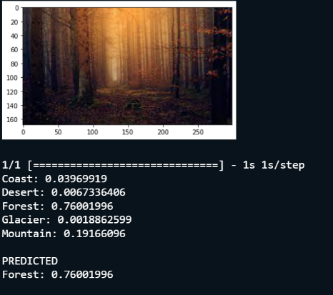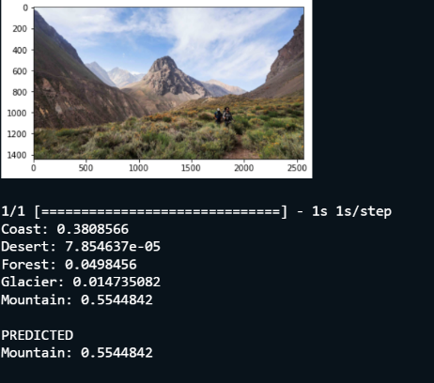

# Problem 2

## Dataset statistics and data generation

Dataset link: <https://www.kaggle.com/datasets/andrewmvd/animal-faces?datasetId=667852&sortBy=voteCount>

The dataset contains 16130 pictures of animals belonging to three classes:

* Dog
* Cat
* Wild

The dataset was splitted in 14630 pictures for the training set and 1500 pictures for validation set.

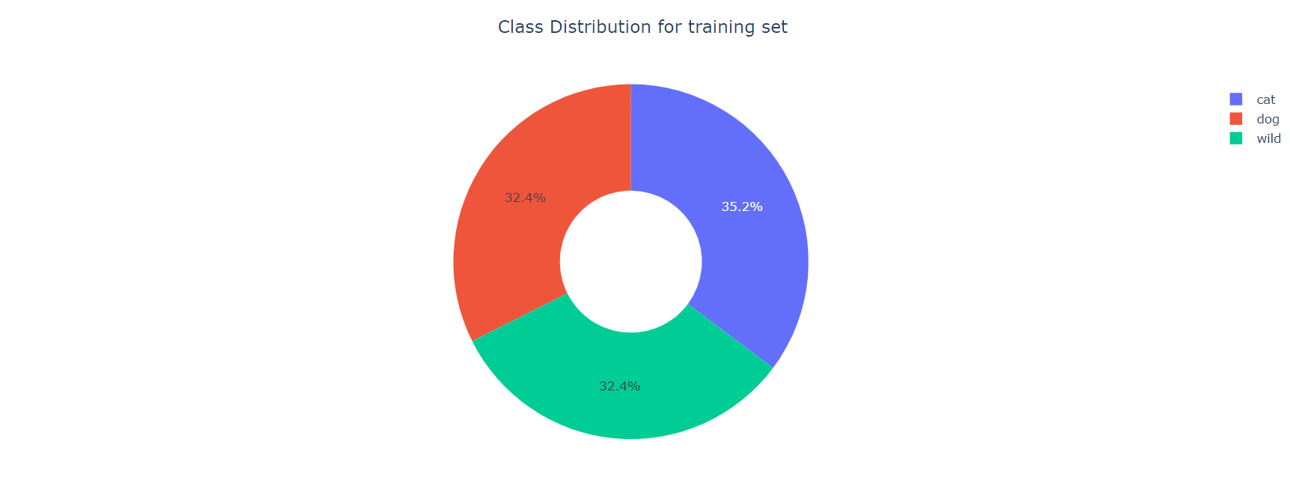

Class distribution for training set:

* 5153 pictures belonging to cat class
* 4739 pictures belonging to dog class
* 4738 pictures belonging to wild class

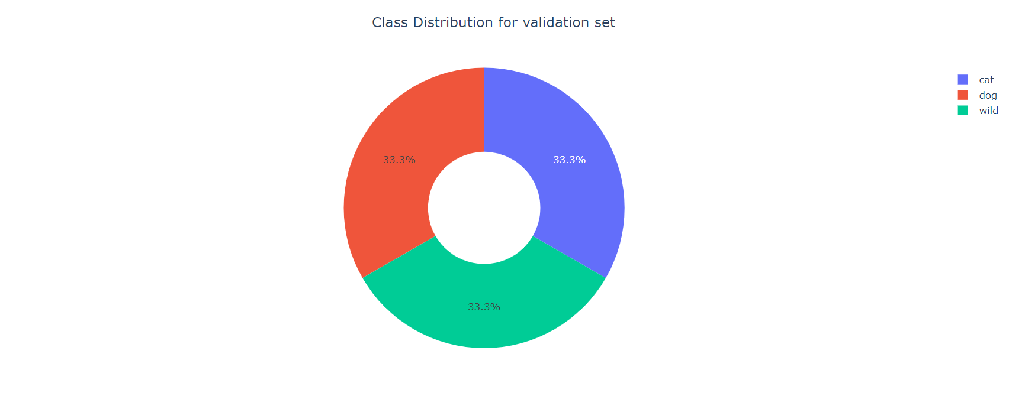

Class distribution for validation set:

* 500 pictures belonging to cat class
* 500 pictures belonging to dog class
* 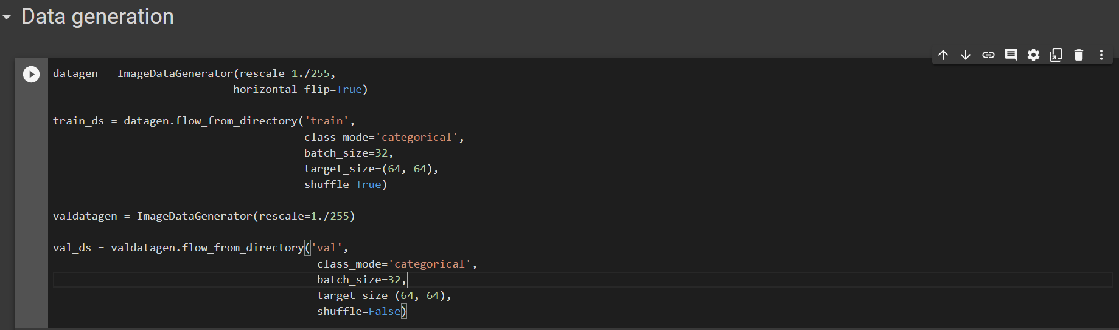500 pictures belonging to wild class

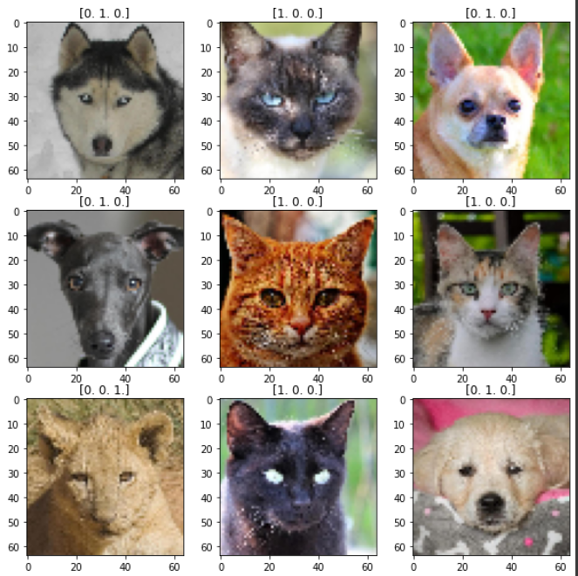

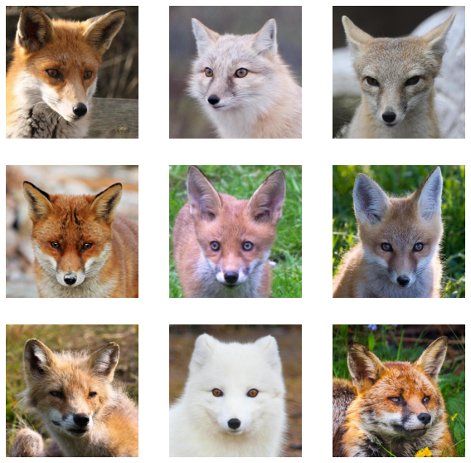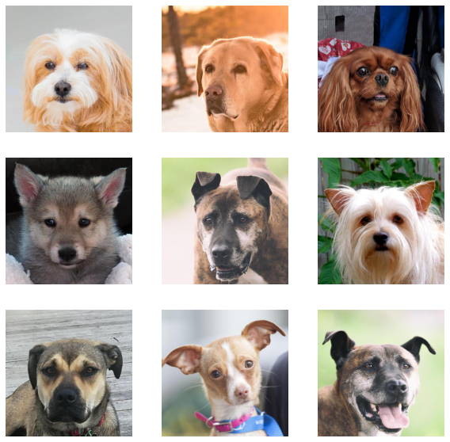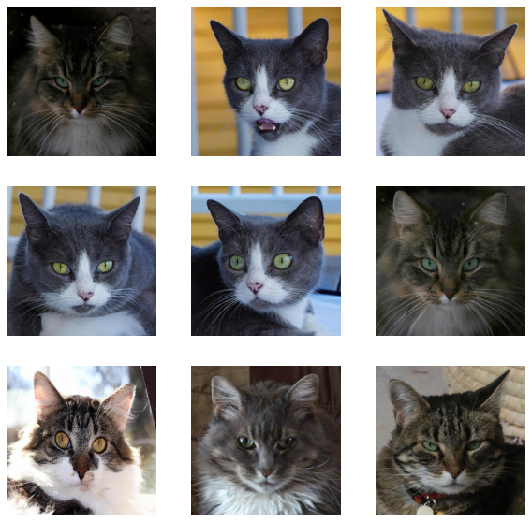

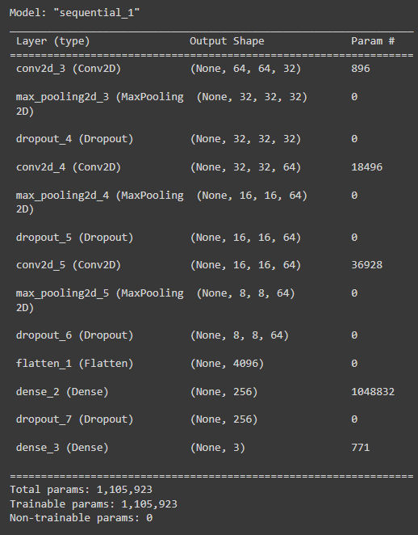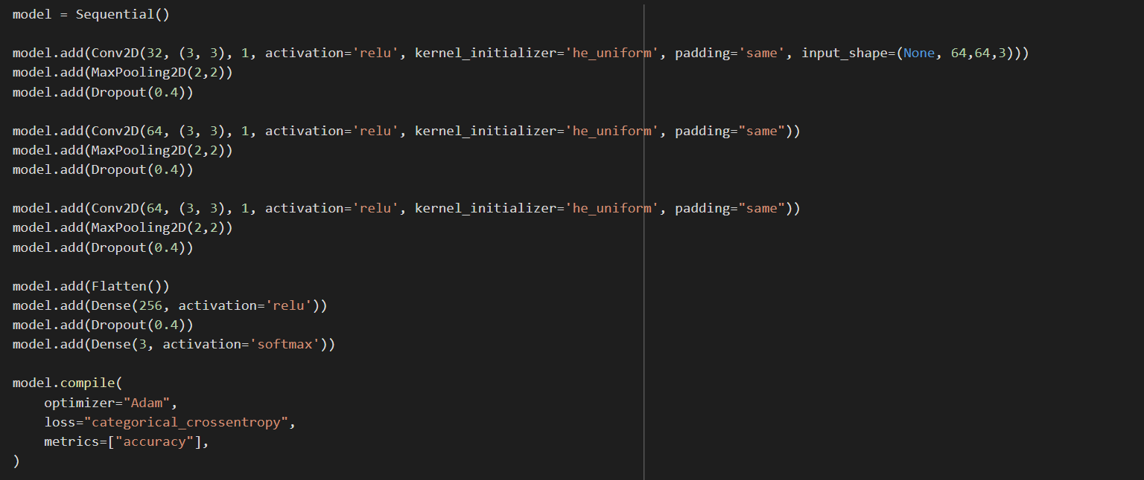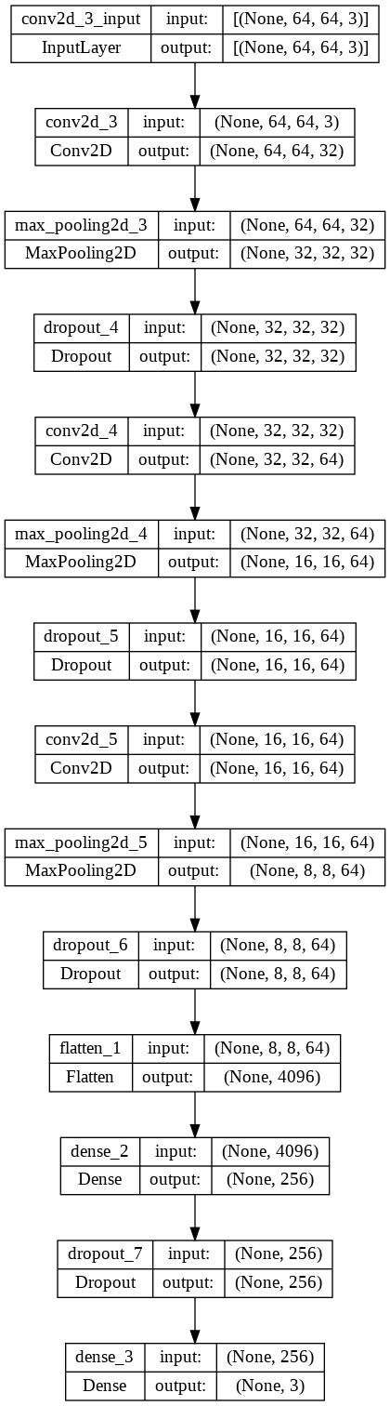

## Text Description automatically generatedA picture containing graphical user interface Description automatically generatedTraining and evaluation

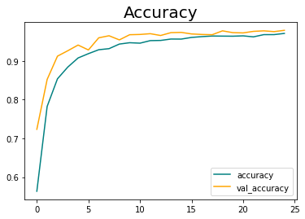

Results with images opened using cv2

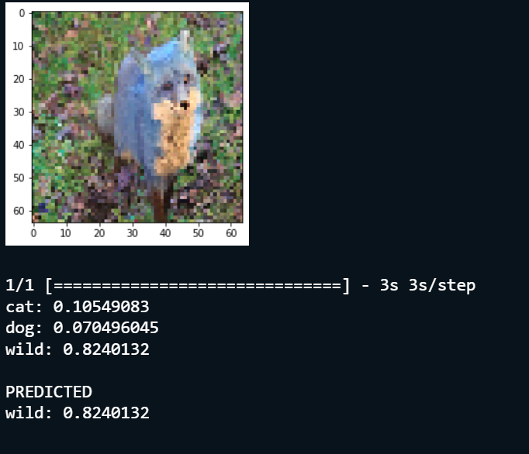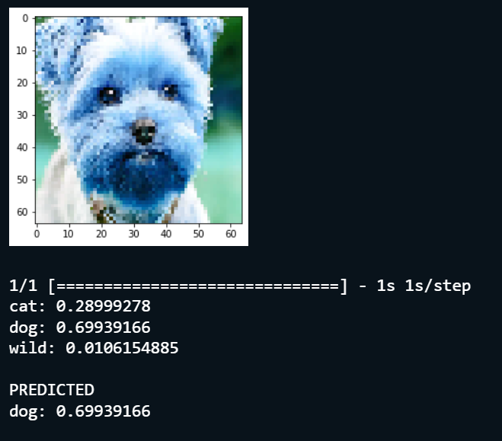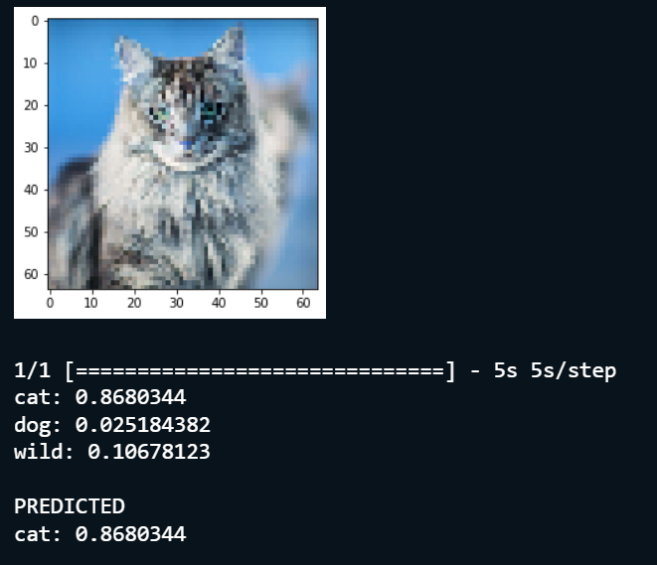

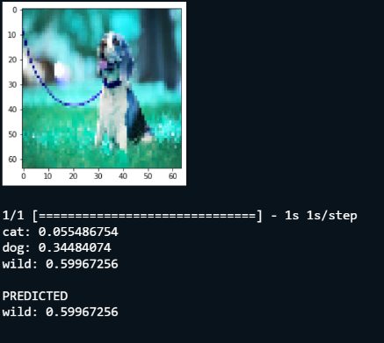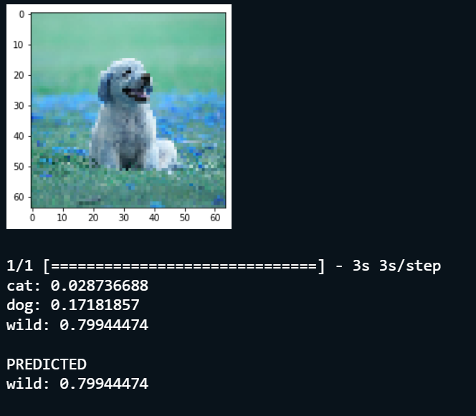

Results with images opened using matplotlib.image

